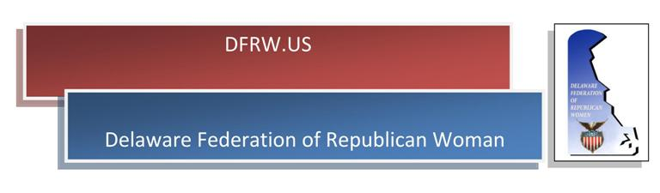
Reservation Request Form

The 67th Annual Convention of the Delaware Federation of Republican Women will be held Saturday, November 2, 2019, at the Boardwalk Plaza Hotel in Rehoboth Beach, Delaware.

The theme of this year’s Convention is Celebrating the 19th Amendment Women’s Suffrage Centennial, 1920 – 2020. Our keynote speaker will be National Federation of Republican Women (NFRW) President, Jody Rushton.

The meeting will convene at 9:00 am with registration/continental breakfast at 8:15 am. Luncheon will also be served. Registration is $50.00. Patrons are $10.00 per name. Checks should be made payable to each Unit Club. Please forward payment and completed Reservation Request to Unit Club Treasurer. Reservations are required and must be postmarked on or before October 24, 2019.

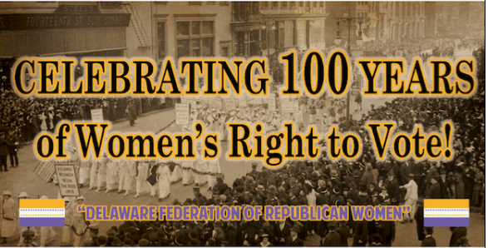

Reservation Request

Name of Attendee(s)___________________________________________________________________

I (we) will attend the entire program______________________________________________________

I (we) will attend continental breakfast and morning session only_______________________________

I (we) will attend only the luncheon_______________________________________________________

I (we) would like to be a Patron__________________________________________________________
($10.00 per name) Please print legibly how name(s) should appear

Check in the amount of $_____________________is enclosed

